L.O.S. van Panache presents the 13th L.P.T.

(L.O.S. van Panache Tournament)

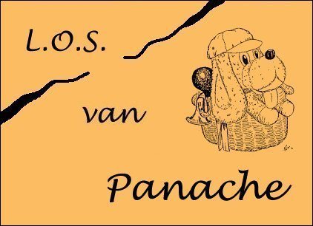

29 June 2024
Studentensportcentrum (Eindhoven)

Organisation: Luuk Oostveen & Ferry Roelofs
Address: losvanpanache@gmail.com
Internet: www.losvanpanache.nl

Tournament Rules
A: We play according to the rules of the L.P.T..
1: Anyone may subscribe.
2: The tournament will start on 29 June 2024 at 11:00 hr, when more than 20 participants subscribed.
3: The tournament will be played in the “Studentensportcentrum” at a walking distance of station Eindhoven
(O.L. Vrouwestraat 1, 5612 AW Eindhoven).
4: The participation fee amounts maximum €10 and shall be paid in the sporting hall.
5: Deadline for registration is 8 June 2024.
6: Subscription is possible in the disciplines single, double and mixed. You can indicate your preferences. According to the subscriptions, the organisation will decide what disciplines you can play.
6a: We will also try to accommodate for a children/youth tournament if there are enough subscriptions. At least, children will be welcome.
7: When there are enough participants, the tournament will be played in 2 categories: I (good) and II (somewhat less good)
7a: Obviously, there is also the category III (children).
8: The tournament will be played according to the A.B.S.-system (see below).
9: Partners will be selected by the organisation.
10: Plastic shuttles are provided by the organisation. When both opponents agree you may play with other shuttles.
11: For those who would like to, we will make reservations for dinner in a restaurant nearby. The dinner costs are at your own expenses.

A.B.S.-system
The Alternative “Brabants” (from the Dutch province Brabant) playing-system (A.B.S.-system) is a so-called keep-on-playing-system. By smart actions from the organisation you will be able to keep on playing (like in a swiss-ladder system). Partners will be selected blindly and randomly by the organisation. Yes really!
The A.B.S.-system is a concept of ing. L. Oostveen en ir. F. Roelofs and has successfully passed all tests so far.
Subscription
Name : M/F
Telephone :
e-mail address:
Category: I II III (children) (indicate your preference)
In case of category III, please indicate age and league level (if any):
Disciplines: (choice of: MS LS MD LD MXD)
Wishes to participate to the diner Yes/No If yes, number of persons:
Date:

